**Lab – Create a DNS Reverse Lookup Zone**

**DNS was installed in Section 2 of the course during the promotion of Server 2012 to a domain controller. Configuring the machine with a static IP address was also done in Section 2 of the course. This lab shows how to create a reverse lookup zone.**

**Overview**

In this lab, students will learn how to configure a DNS reverse lookup zone.

Normal DNS queries are forward lookup queries; they request the IP address that corresponds to a fully qualified domain name. A reverse lookup is the opposite of a forward lookup: It returns the fully qualified domain name of a host-based on its IP address.

Reverse lookups are possible because of a special domain called the in-addr.arpa domain, which provides a separate fully qualified domain name for every possible IP address on the Internet.

**Lab Requirements**

* One install of Server 2012 or 2016 with the Domain Name Service (DNS) role installed.
* One install Windows 10 client for testing IP address to domain name resolution

**Begin the lab**

Using your Server Manager, in the upper right-hand corner, click on Tools and from the Tools menu, click on the DNS snap in to open the DNS Management Console.

Begin by right-clicking on the Reverse Lookup Zones container and selecting New zone.

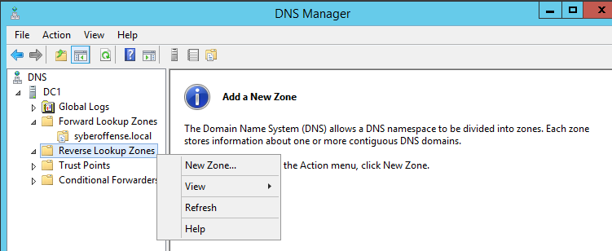

Once the New Zone Wizard opens, click next.

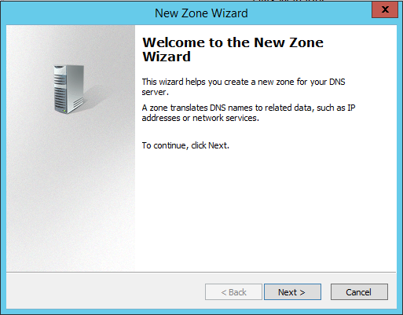

This will be a primary zone. Click next.

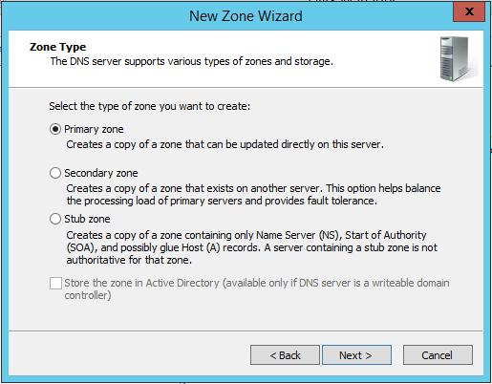

This will be an IPv4 Lookup Zone.

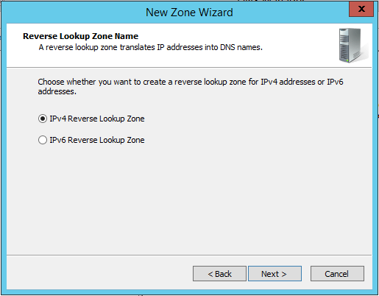

On this next page, I type in the first three octets of my IP address. This is the network portion of my IP. Click next.

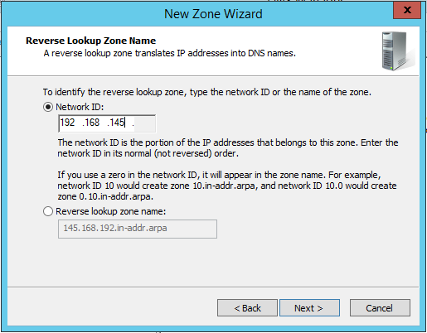

Accept the defaults for the zone file name.

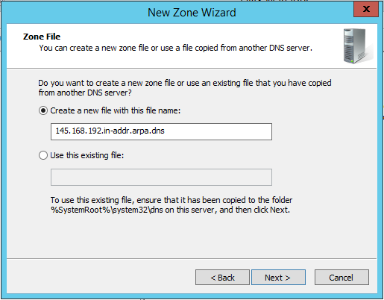

Allow both nonsecure and secure dynamic updates.

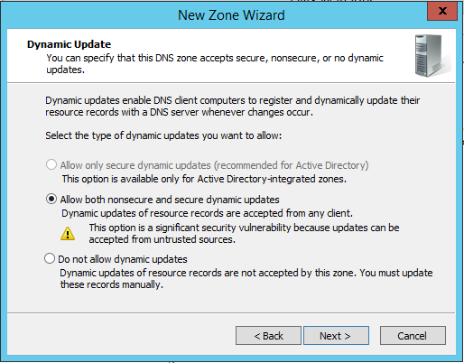

Click Finish to close the wizard.

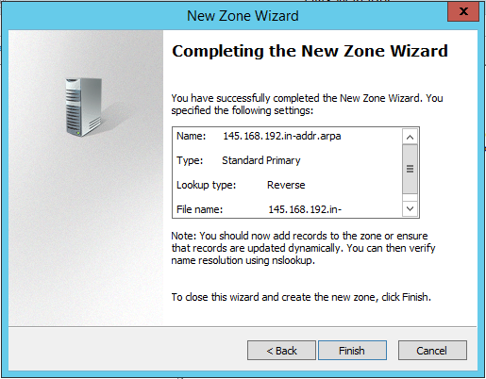

**Testing your new reverse lookup zone**

From the desktop of your server, open a command prompt and attempt to ping the IP address of your server.

For DNS to respond with the fully qualified domain name (FQDN), we need to add -a in front of the ping command.

Ping -a 192.168.145.10

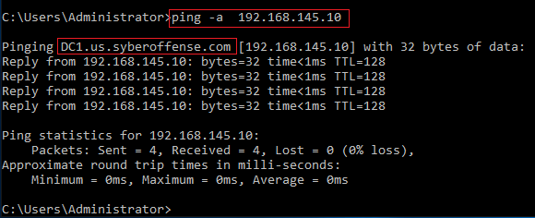

If your reverse lookup zone is working correctly, you should receive back a response showing you the fully qualified domain name IFQDN) of the server.

Let’s see how our forward lookup zone resolves a name to an IP address.

Unless we tell ping to resolve an IPv4 address, it resolves using IPv6 which is the default for newer operating systems (2016). At the very front of our ping command we need to add a -4 so it will know we want IPv4 address information and not IPv6.

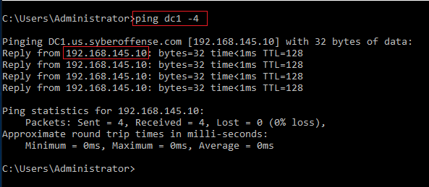

**Summary**

In this lab, you created a reverse lookup zone. This lab represents how DNS is configured on roughly 85% of all Microsoft networks using a simple network design. DNS is dynamic, and if kept simple, will normally work flawlessly, but issues do happen. DNS can be repaired by removing and reinstalling the corrupted zone or the DNS role itself. It’s easy enough to bring a new DNS server online, make it the primary and take the original offline or reduce it to be a secondary backup.

End of the lab!